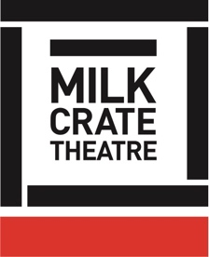
Milk Crate Theatre Online Program 2020

DEVISING THEATRE – 04

CHARACTER CREATION 01

CLASS:

Creation of a character who is not you.

Why we do this, why we need separation, not just for personal safety, but also integral artistic reasons.
Not using personal experience to directly inform material – ie reliving, rehashing or retelling experiences that may be re-triggering to the individual

CREATING CHARACTER

There are many ways to begin creating a character.

We will be setting you a task at the end of this video, as an example of ONE way to start.

But here are some other ideas!

- Being inspired by a costume
- Being inspired by an object
- Experimenting with makeup
- A photograph of someone in a crowd, or someone you know, or see on the bus
- Through physicalisation – eg tight hands, loose shoulders
- Being inspired by an artwork
- Being inspired by a song or music
- Habitual gestures or words

From these inspirations you can start writing, or moving, or recording some improvisation etc etc

Depending on what it is you are creating, you can then develop a narrative or back story for this character as a story on its own, or, if this character is being created for a collaborative work, you can connect with your team to develop your characters together.

So many options!

TASK:

Answer this list of questions:

- Name
- Age
- Location / Place / Space
- Occupation / Activity
- Likes
- Dislikes
- A Secret
- Closest Relationship
- Body:
  - Rhythm
  - Pace
  - Posture / Level

Using your answers from this list, create a one page monologue introducing your character.
Please write it in the “third person” – ie using “he” “she” or “they” rather than “I”.

