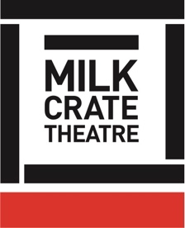
Milk Crate Theatre Online Program 2020

DEVISING THEATRE – 07

MOVEMENT + CHARACTER CREATION 03

Before we start – go back to our Introduction video / worksheet if you need a refresher on pace, rhythm, and levels. This will prove very handy for exploring character movement!

CLASS:

Experimenting with movement – just like with objects, or writing, or anything else! – can inspire material useful for your character development. As we discussed in Week One, there are many different movement and physical processes to explore.

Movement is an alternate form through which to tell story.
What are some examples of stories you have seen that are told without words? How have these affected you and your understanding of a character, their history, or narrative in general?

There are SO MANY WAYS to investigate movement! We can’t cover them all here, but some examples include:

- Leading with different parts of your body – ie, walking around the room being led by your nose, or your elbow, or your stomach
- Playing with tension in different parts of the body
- Noticing where you carry anger/anxiety/love/hope in your body – use this to explore your character, and see how that might affect how your character is operating

TASK:

Take your character description / list of answers from Week 4
- Circle 10 words
- Make a movement or gesture for each of these 10 words
- Put them together in a sequence
- Consider the transitions between each movement

Film or record yourself doing this sequence, or write a list of the movements, or draw them, or present in our follow-up zoom session!

