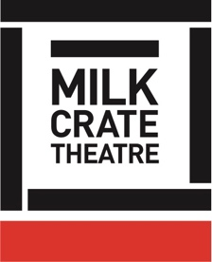
Milk Crate Theatre Online Program 2020

DEVISING THEATRE – 10

NARRATIVE

CLASS:

What is narrative?
What are the common forms of narrative that we know?
What is the purpose of narrative?
Once we know a narrative arc, how can we mix it up or mess with it? What are some examples of this?
Ie
- Ocean Vuong, Studio Gibli
- Seinfeld ‘Show about nothing’
- Waiting for Godot

The “Aristotelean”, common narrative arc:

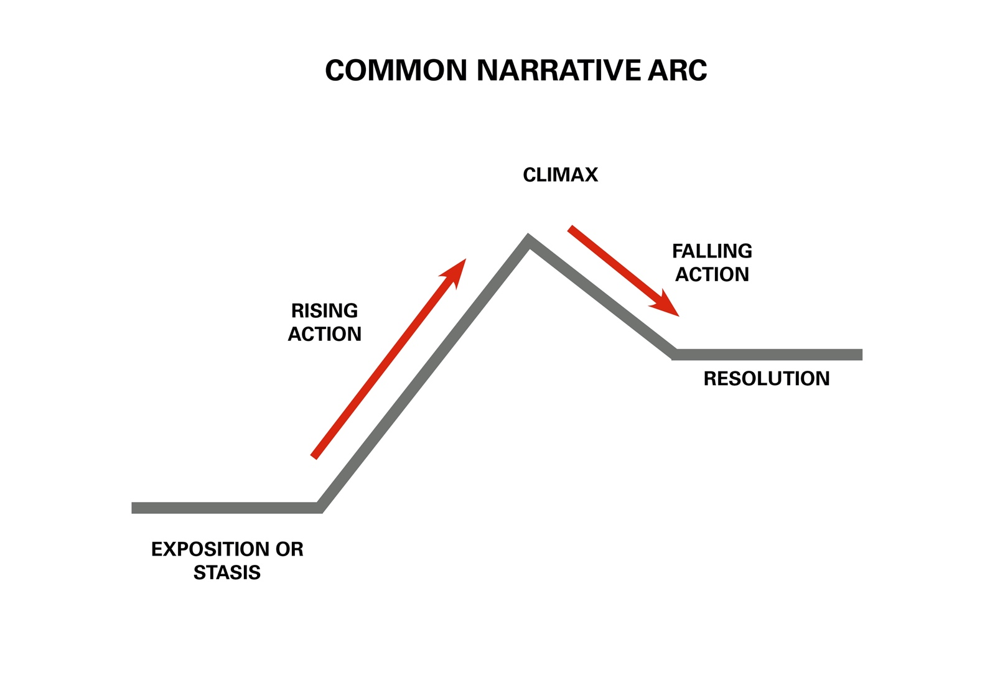

Another example of narrative arc:
Kishotenketsu



Things to also consider:

- Story narrative vs individual narrative
- Narrative of a scene or moment in time vs full story narrative
- Point of View

TASK:

Write a narrative for your character. This does not have to be too long, or a whole life history!
It can be a list if you like.

Consider the important or landmark moments in your character’s life.

See if you can draw this narrative as a diagram!

